# Design of a Scramjet

# By Nandan Madhuj & Shraman Das

**Introduction**

Interest in hypersonic travel has been increasing for several years due to its potential uses in military, space, and possible civilian applications. This mode of travel can not only save time for long travels but also significantly reduce the cost for space launches.

The hypersonic aircrafts experience extreme thermal and aerodynamic conditions. Their design and development are in many ways different from traditional aircrafts in which engines and main body may be developed separately. Further, the need for specialised cooling systems in supersonic/hypersonic aircrafts further demands innovative methods.

The Scramjet concept has been around since the 1950s. Alexander Kartveli and Antonio Ferri were proposers of scramjet at that time. Several ground engines were constructed and tested under them. However, due to governmental secrecy, and high testing costs, the scramjet development has progressed slowly around the globe.

We discuss in this term-paper, the principles behind the scramjet engine, the designing difficulties and innovations being employed by current researchers and engineers to develop the scramjet technology into an actual usable one rather than just a research interest.

**Jet Propulsion**

Propulsion produced by ejecting a jet of fluid in the direction opposite to motion is called jet propulsion. This method is extensively used by modern aircrafts to produce thrust.

Engineers by the 1930s had realised that the maximum performance of the piston engine was limited. The propulsion efficiency at the blades greatly declines as the aircraft approaches Mach 1. Hence, it was impossible to construct a supersonic aircraft using the technology of that time.

In 1928, Frank Whittle started working on the turbo-jet technology. By 1935, Germany too was working on a similar design. And the world saw first turbo-jet engine ready and tested by 1937.

Interestingly, Germany started working on jet propulsion only after UK, however, their progress was significantly faster. Germany could’ve produced an array of war altering jet-propelled military aircrafts if there weren’t many alterations in design and delays in manufacturing.

The victorious allies extensively studied the German engines post WWII. As a result, we note that jet engines of almost all fixed wing aircrafts have some inspiration from the German axial-flow jet engine.

We also find that by 1950s, jet propulsion was the mainstay military engine. By 1960s, almost all civilian aircrafts were jet-driven.

**Air Breathing Jet Engines**

The principle used in air breathing engines is – increasing pressure and temperature of the intake air to increase its energy and converting this energy into kinetic energy of the flow as the air expands and is ejected out.

Though there are several types of airbreathing jet-engine, we briefly discuss the turbojet and ramjet engines before scramjets because these are the precursors of the scramjet engine.

**Turbojet Engine**

The turbojet engine was the first jet engine developed in the world, independently, by English and German scientists. The modern turbojet engine has the following design components:

1.Air Inlet

2.Compressor

3.Combustion Chamber

4.Turbine

5.Nozzle

The figure shows parts of a typical turbojet - the inlet delivers atmospheric air to the compressor at a desired pressure and velocity. It is important to note that air flowing into the engine must always be subsonic regardless of aircraft speed.

The compressor – driven by the turbine – is responsible for slowing down the air by increasing its pressure and temperature. This is essential because combustion is more effective in these conditions. The compressor is a significant component of these engines. The compressed air is used not just for thrust generation, but also in anti-icing, environment control systems and pressurizing the fuel tank. The part of air utilized for this purpose is said to be “bleed air” as this part cannot contribute to thrust and decreases the engine efficiency. However, without the bleed air, the engine would probably overload, parts of it will melt, ice would form on the inlet nose and turbines would overheat.

Within the engine, the air from compressor enters the combustion chamber, where it is mixed with fuel and ignited in a controlled environment to impart high energies to the flow at a steady rate.

Hot gases from the combustion chamber are expanded through the turbine and are speeded up. The rotating turbine further accelerates the air. As the accelerating air expands through the exhaust nozzle, the nozzle produces high velocity jet which propels the aircrafts forward at high speeds.

The turbojet and other turbine-driven jet engines are very efficient at high altitudes. These engines and their improvements – with afterburners etc – are the mainstay engines for flight up to Mach 2. Above this, they start losing efficiency and produce significant drag. These engines are very noisy, hence unsuitable for low altitude flights.

**Compression at Intake**

The engine works efficiently within a small range of conditions. Hence, the air inlet must deliver air with only slight pressure variation. As the air is rammed into the inlet, the flow sees a rise in pressure. This air compression becomes increasing important at high speeds. At higher Mach numbers, it even surpasses the compression done in the compression chamber. From the available data, A Concorde at Mach 2 saw intake compression and engine compression contribution to total compression as 63%/8%. For the Lockheed SR-71 Blackbird, which flew at Mach 3+, this contribution was 54%/17%.

**Ramjet engine**

The compression of air at inlet due to the ram effect becomes more and more significant at higher Mach numbers until we essentially do not need a compressor. That is the principle behind a ramjet engine – getting rid of the compressor and other rotating parts and compressing the air literally by ramming it into the inlet.

These engines are very efficient between Mach 2 to 5. And form the basis of supersonic and hypersonic flight in this range.

In principle, the ramjet engine is much simpler than a turbine-driven jet engine. It doesn’t possess as many weak points as the turbine engine with its multiple complicated co-axial rotations. However, the ramjet engine undergoes extreme thermodynamic conditions and aerodynamic drag which pose a significant engineering challenge in designing and controlling these engines.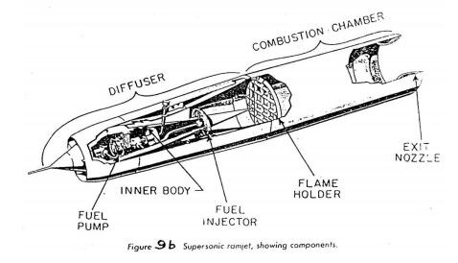

Broadly, modern ramjets have the following components:

1. Diffuser
2. Combustor
3. Nozzle

The work of compressor is done in the diffuser. The diffuser in the ramjet engine is responsible for compressing the air i.e., decreasing velocity and increasing pressure.

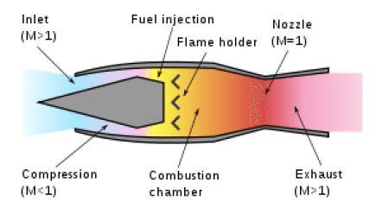At subsonic and lower supersonic Mach numbers, a pitot tube like inlet is used as the diffuser. The inlet forces air into the engine, within which, the area increases. Hence, by mass balance on the flow, the velocity within the engine decreases to subsonic level. For higher Mach number flights, special structures called shock cones are placed in front of the diffuser. These utilise shock waves to considerably slow down the air to subsonic speed within the diffuser. Hence, within the ramjet, air is subsonic.

The subsonic air is mixed with fuel and ignited in the combustion chamber. For this, a sheltered area called the flame holder exists within the combustion chamber – which doesn’t let the flow within the chamber to affect the flame (even under sudden yaw/pitch moments).

The subsonic-burned-air is accelerated as it passes through a nozzle. For high-speed aircrafts, a convergent-divergent nozzle is used to accelerate the flow to higher supersonic speeds than the surrounding air.

**Supersonic Combustion Ramjet Engine**

A supersonic combustion ramjet engine (i.e., scramjet engine) is a variant of the ramjet engine. Essentially, if an aircraft would go beyond Mach 6, then slowing the air down to subsonic speeds inside the engines becomes unsuitable.

Since thrust generation involves increasing the energy of the air via combustion of fuel, the combustion temperature of fuel must be higher than the temperature of surrounding air to impart meaningful energy to the flow. However, slowing down hypersonic air to subsonic speeds creates very high temperatures of almost the same magnitude as the combustion temperature. That is why the ramjet efficiency decreases at Mach number > 6.

A scramjet slows down the air, but the flow stays supersonic all through the engine. The temperature within the combustion chamber is significantly lower than the combustion temperature. Hence, energy can be added to the flow and significant thrust can be generated.

However, this is easier said than done. Designing a Scramjet is a huge technical challenge. And engineers have only recently achieved powered scramjet flights.

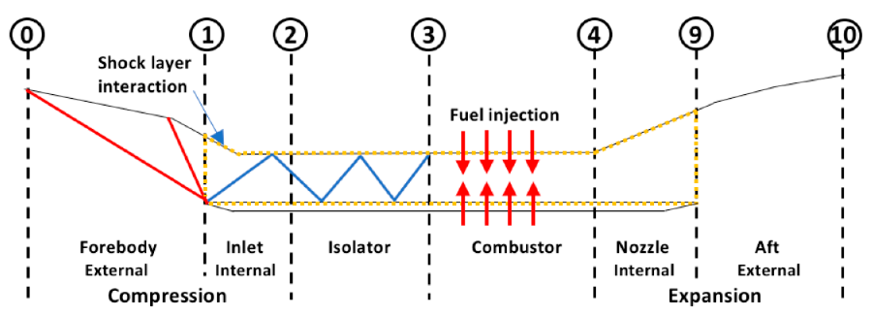The scramjet engine broadly comprises of the following sub-divisions:

1. Converging inlet
2. Isolator
3. Combustion Chamber
4. Diverging Nozzle

**Inlet**

The Sections 0 to 3 in the figure show the region where compression takes place. It is important to note that the main body of the aircraft plays an important role in the inlet. The inlet mouth is not large enough to provide high-enough mass flow into the engine. Hence, the aircraft is specifically designed keeping the engine in mind. (Unlike traditional jet engines in which engines are developed independently.)

Section 0-1 provides external compression to the flow due the aircraft body. This is done to increase the mass flow into the engine. The geometry is the key feature in compressing the air because the air must enter the engine at a suitable pressure, temperature, and high mass flow rate.

Broadly, following compression methods may be employed depending on the need of the scramjet engine:

1. External Compression
2. Internal Compression
3. Mixed compression

The figure shows an arrangement which uses mixed compression. Part of the compression takes place outside the engine – due to the geometry of the aircraft and part of the compression takes place within the engine – due to geometry of the inlet and isolator between section 1-3.

Importantly, the inlet must capture the maximum amount of possible mass. As leakage becomes a cause of drag called – spillage drag. Hence, the angle of cowl with free stream is kept minimum. This means that the aircraft must not undergo sudden yaw/pitch moments. This limits the scramjet aircrafts to cruise flights in almost straight-line paths. Further, the accession/ descension of the aircraft must take place at a pre-determined rate (depending on speed) in a controlled manner.

The inlet length is generally reduced to decrease the weight of the aircraft while also maintaining the shock wave criteria. This puts limits on fuel efficiency and consequently on maximum speed and flight range.

**Shockwaves in a Scramjet**

Shockwaves are very strong pressure waves in media, such as air or water, that cause drastic changes in properties such as pressure, stress, density, and flow speeds across them. They travel faster than the speed of sound, but their amplitude also decreases faster as the energy is dissipated via heat into the medium. Shockwaves are caused by aircrafts which travel at supersonic speeds. We now discuss shockwaves which are used by the scramjet inlet for compressing the air.

There are two types of shockwaves: Normal Shock Waves and Oblique shock waves.

A normal shockwave is perpendicular to the incoming flow. The sudden change in airflow properties across a normal shock wave are given by the famous Rankine-Hugoniot conditions:

Density:

Pressure:

Temperature:

Mach Number:

After passing through a normal shock, the entropy of the air and its density increase, but the stagnation temperature remains the same. As there is ideally no heat exchange taking place. However, the stagnation pressure drops. Due to drastic drop in stagnation pressure, the fuel efficiency also decreases drastically. Mach number usually goes from supersonic to subsonic across a normal shockwave. Hence, the strong shock waves are generally avoided within a scramjet – which requires that flow stay supersonic.

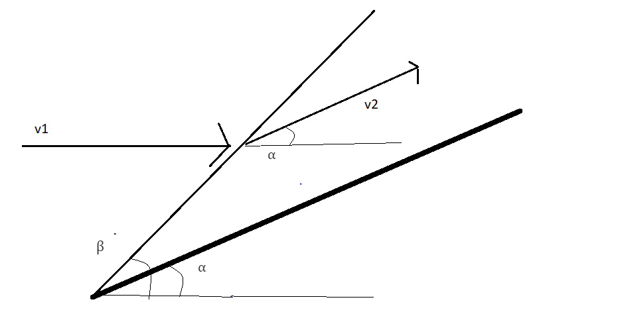An oblique shockwave is not perpendicular to the incoming flow. In the adjoint figure, the bold line represents the intake surface, at an angle with the reference. It produces an oblique shock at an angle with the reference.

If V1 be the velocity of incoming flow particles, after the oblique shock, the flow direction changes parallel to the surface, with speed slightly decreased depending on the shock wave angle and the flow deflection angle. The flow properties change in a similar manner as in a normal shock.

If be the deflection angle for the flow, then:

For a given free stream Mach number M1, and deflection angle , we can have the following solutions for oblique shock wave angle .

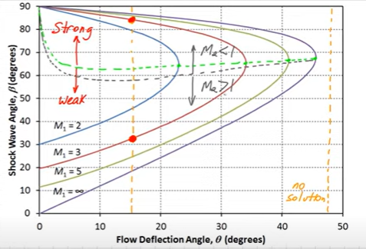

For cases with 2 possible solutions, the smaller shock wave angle corresponds to a weaker shock, while the larger angle implies stronger shock.

A single solution occurs when there is flow deflection angle is maximum (max) for a given M1.

No solution occurs if deflection angle exceeds (max) for the given Free stream Mach number.

A green line in the graph is obtained by joining max for every from 0o to 90o. Every solution above this green line gives a strong shock, while solutions below the line represent weaker shocks.

The grey line, below which the Mach number of the flow stays supersonic after crossing through the shock, is shows crucial information for allowed flow conditions within scramjet engine.

If the flow is initially supersonic, it undergoes slight reduction in speed, increase in pressure and density for regions below the grey line. All flows corresponding to region above the grey line become subsonic after undergoing the shock.

The grey line is very close to the green line. A strong shock will always be accompanied by reduction of flow speed to subsonic, which must be avoided in a scramjet engine. Hence, a scramjet engine should ideally have weaker shocks, where the flow is likely to stay supersonic.

Thus, the inlet is developed in such a manner that it creates oblique (weaker) shockwaves which redirect the incoming flow, reduce its speed (keeping it in supersonic range), and increase its pressure and density.

**Isolator**

As the name suggests, the isolator “isolates” the inlet flow from the combustion chamber. It is essential to prevent interaction between the combustor and the compression inlet because the incoming flow may be perturbed by the conditions of combustion chamber.

The isolator also contains the shock train which is unavoidable wherever supersonic flow is slowed down to increase pressure.

Further, the pressure in the isolator (region 2-3 in the scramjet figure) affects the flight significantly. The ratio of pressure present within the isolator and the free stream pressure is called the compression ratio. The adjacent graph shows the variation in overall efficiency of a research scramjet for different free stream Mach numbers. The Mach numbers within the engine were 2 – 3.

As can be seen from the graph, a decrease in efficiency occurs at compression ratios higher than 80 for all freestream Mach numbers. Hence, the best choice for compression ratio is generally assumed to be 50-80.

**Combustion Chamber**

The basic concept of air breathing propulsion is to increase the enthalpy of the intake air (by increasing pressure or temperature) and then convert this enthalpy into kinetic energy (usually using a nozzle) which will produce thrust by Newton’s third law.

The combustion section (3-4 in the scramjet figure) is where combustion takes place. Here, fuel is injected into the flow and gets ignited without the use of burners due to extreme temperature and pressure conditions.

The injection of fuel via fuel injectors can be done by two main methods:

1. Circumferential injection
2. A strut injector at the centre

The first method involves injecting the fuel at high speeds into the flow from the walls of the combustion chamber. The second method involves injecting it from the centre of the chamber. Placing an injector in the centre of the flow adversely affects the streamlines. Hence, earlier research in scramjet designing focussed more on circumferential injection. However, recent developments favour the strut injection in which fuel-air mixture readily forms on its own compared to circumferential injection, which requires injection of fuel at high kinetic energy for sufficient mixing.

This diagram shows the shape of the strut injector which is placed at the centre of the flow. The mixing of fuel and the composition of flow within the engine during steady cruise flight has been calculated using CFD in the research paper [Numerical investigations of Model Scramjet Combustors](https://www.researchgate.net/publication/225000848_Numerical_Investigations_of_Model_Scramjet_Combustors).Diagram

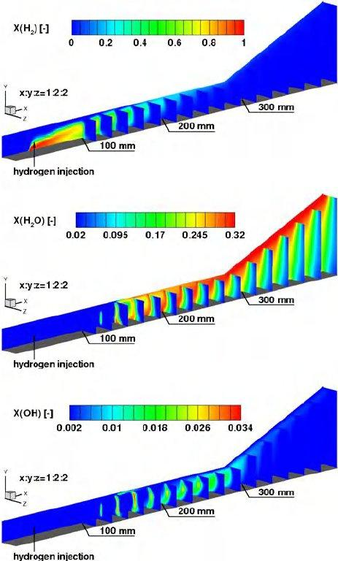The below figure shows the injection and combustion of H2 fuel taking place in a scramjet engine via the strut injection in first figure and a HyShot injection in the second figure.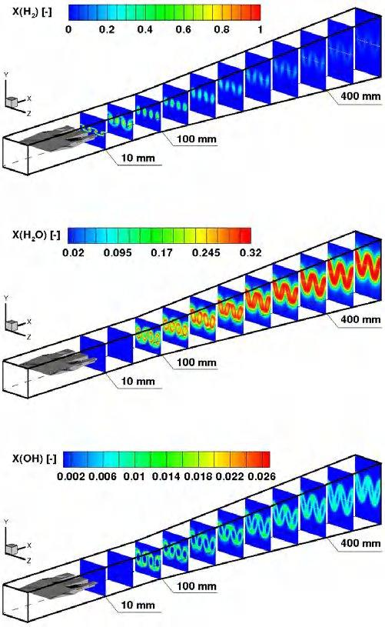

The fuel mixture in the combustion chamber contributes to compressing the air by creating backpressure and shockwaves that slow and compress the air before ignition. Higher the fuel flow and combustion, the more shockwaves are formed ahead of the combustor, which slow and compress the air before ignition.

To keep the combustion rate constant, the pressure and the temperature must be kept constant. This is difficult, as these parameters vary with altitude. Since density decreases with increases in altitude, the scramjet must climb at a specific rate as it accelerates or maintain a constant altitude at a given speed to keep the pressure at the intake constant.

In general, a scramjet must have a high Mach number for compression. Yet the flow may not be completely burned at high speeds within the engine. Hence, several engines use an afterburner which further facilitates complete combustion.

The speed within the engine should not be slowed below Mach 1 in the combustion chamber, otherwise it will cause choking thereby increasing the pressure, accelerating the rate of reaction and hence lead to an explosion in combustion chamber.

Uncontrolled combustion within the scramjet will lead to increased pressure would mean increased speed of sound, thereby reducing the Mach number. This may lead to thermal chocking if the Mach number drops below 1.

**Propellant**

An advantage of air breathing hypersonic vehicles is that they do not need to carry onboard oxidiser unlike rocket engines. They only need to carry fuel onboard. Fuels like liquid hydrogen have a very high calorific value but due to their low density they occupy a larger volume which makes the aircraft shape bulkier and hence increases drag. Other fuels like RP-1, JP-7, unsymmetrical dimethylhydrazine have more density but comparatively lower calorific value.

**Nozzle**

After the combustion chamber, the burned air-fuel mixture expands through the nozzle. Energy is extracted from this mixture as it loses pressure and temperature. As the mixture is exhausted out into the atmosphere with velocity higher than the free stream velocity, thrust is generated. For perfect expansion, the ideal nozzle should have pressure equal to the ambient pressure outside it.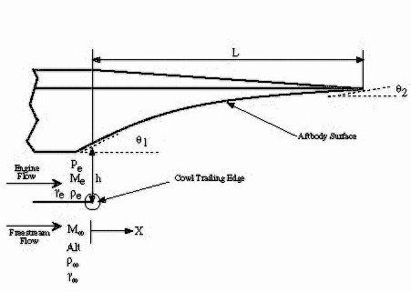

Hypersonic vehicles require very long nozzle length. Theoretically, the required nozzle may be even longer than the aircraft length. This is of course impossible to design. Hence, the hypersonic aircrafts use an aft for further expansion of the air.

Here, part of the air expansion takes place inside the nozzle, and part of it takes place due to the aft of the aircraft. Hence, the combined geometry works as a long nozzle.

**Cooling and Insulation**

High speed of scramjet engine causes severe thermal conditions on the aircraft, and even worse conditions on the engine itself. The high drag generated at these speed produces a lot of heat. To protect the aircraft against heat, materials like aerogels, cryogenic foam, silica tiles etc are used. These materials are also used in Space Launch Systems and Vehicles which hit high Mach numbers.

Due to combustion in the engine, it must be continuously cooled down, to prevent melting. This may be done by circulating a coolant through the engine. If hydrogen is the fuel, then it can also be used as the coolant. In this arrangement, the fuel get pre-heated to optimum temperature before being injected, while the engine itself gets cooled down. This is called regenerative cooling and is used in cryogenic engines in spacecrafts. It is a method of Active Cooling.

Another method of Active cooling is injecting cooling material through a slot or porous walls. Coolant may be air or fuel, or some other liquid carried by the aircraft.

The methods for cooling a scramjet aircraft known till now are active. The aircraft expends some energy (or efficiency) to actively cool itself. Hence, the design of scramjet (like any other design) is a trade-off between maintenance and performance.

**Aircrafts with Scramjet engine**

As discussed earlier, a major difference between traditional engine and scramjet engine is that the engine and the aircraft must be developed together. The parts of aircraft like aft etc contribute to the engine intake and nozzle performance. Hence, the scramjet engine is integrated into aircrafts. Those which are not integrated into an aircraft are generally for research purposes and technology demonstrators.

**ISRO’s Advanced Technology Vehicle**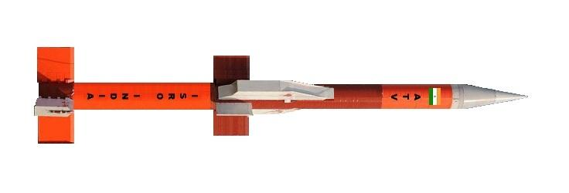

The ISRO has conducted two successful scramjet tests under the Advanced Technology Vehicle (ATV) program. The aircraft, which is a modified Rohini-560 rocket, reached Mach 6 in one of the tests. The below figure shows the Rohini rocket with scramjet engine.

**NASA’s X-43**

This is currently the fastest aircraft which flew with an air-breathing engine. It achieved the flight of Mach 9.6.

The main body and the engine of the craft are integrated to provide maximum intake and for external expansion. This integrated configuration also significantly decreases the drag on the aircraft. Which would be high if the engine was to be mounted on the sides.

**Development of Scramjet**

Though the concept of scramjet engines has been around for almost 70 years, we have only recently achieved sustained powered flight for a few seconds. Several factors have hindered the development of this futuristic yet increasingly relevant technology. We discuss them here:

**Testing Difficulties**: The cost for testing a scramjet engine is very high. The unavailability of ground facilities has further hindered testing. The experiments are generally done on separate parts and require several separate testing facilities. Further, testing the integrated engine-aircraft system is even more difficult.

**Computational Difficulties**: CFD is extensively used for scramjet research, however, the modelling fast reactions and extreme conditions within a scramjet puts strain on the computational power and is often times very-very slow.

**Scarce Literature:** The development of scramjet has long been done in secret via the developed countries. The data has largely remained classified as the programs like US Navy’s SCRAM engine or NASA’s Hyper X program (X-43A) have claimed successful testing, yet haven’t publicly released their data till date.

**Conclusion**

A brief introduction to jet engines was presented in this paper, discussing the major differences between the turbojet, ramjet, and scramjet engines. Design principles behind scramjet engines and its various parts were discussed. The methods of compression at intake, fuel injection, combustion, expansion at nozzle and active cooling were discussed along with the reasons for slow development of scramjet technology. Two of the real scramjet-propelled aircrafts were shown, one developed by ISRO, and the other by NASA several years ago. Several other scramjet aircrafts are right now in development which were not discussed due to limited information available. Scramjet technology has been said to be only “2 years away” for the past 20 years, however, only now do the developments look favourable.

*References*

[*Jet propulsion - Wikipedia*](https://en.wikipedia.org/wiki/Jet_propulsion)

[*Airbreathing jet engine - Wikipedia*](https://en.wikipedia.org/wiki/Airbreathing_jet_engine)

[*Turbojet - Wikipedia*](https://en.wikipedia.org/wiki/Turbojet)

[*Ramjet - Wikipedia*](https://en.wikipedia.org/wiki/Ramjet)

[*Scramjet - Wikipedia*](https://en.wikipedia.org/wiki/Scramjet)

[*The Ramjet Engine (brainkart.com)*](https://www.brainkart.com/article/The-Ramjet-Engine_5099/)

[*Experimental Simulation of Flame Holding in Air-Breathing Engines (researchgate.net)*](https://www.researchgate.net/publication/306395631_Experimental_Simulation_of_Flame_Holding_in_Air-Breathing_Engines/figures?lo=1)

[*(PDF) Numerical Investigations of Model Scramjet Combustors (researchgate.net)*](https://www.researchgate.net/publication/225000848_Numerical_Investigations_of_Model_Scramjet_Combustors)

[*https://www.youtube.com/playlist?list=PLf_lu4AHS69DIa7Y2uNpMiY4SWNs7EFAy*](https://www.youtube.com/playlist?list=PLf_lu4AHS69DIa7Y2uNpMiY4SWNs7EFAy)

[*https://www.youtube.com/watch?v=AMadcKOW6j8*](https://www.youtube.com/watch?v=AMadcKOW6j8)

[*https://www.youtube.com/playlist?list=PLbMVogVj5nJR0Vt9CLGK7ck2yrS1zQjMo*](https://www.youtube.com/playlist?list=PLbMVogVj5nJR0Vt9CLGK7ck2yrS1zQjMo)

[*A Scramjet Compression System for Hypersonic Air Transportation Vehicle Combined Cycle Engines*](https://www.mdpi.com/1996-1073/11/6/1568/htm)

[SCRAMJET NOZZLE DESIGN USING METHOD OF CHARACTERISTICS (researchgate.net)](https://www.researchgate.net/publication/283303004_SCRAMJET_NOZZLE_DESIGN_USING_METHOD_OF_CHARACTERISTICS)